**SELECTION OF REQUIREMENTS USING**

**FUZZY TOPSIS METHOD FOR LIBRARY**

**MANAGEMENT SYSTEM**

**Eight Week Industrial Training Report on Software Development**

**(February 20, 2023- April 14, 2023)**

Submitted by

**Nandini Thakur, Btech -II year**

Department of Computer Science and Engineering

**Indian Institute of Information Technology**



**Division of Communications and Information Technology**

**Indraprastha Institute of Information Sciences Delhi**

**(A Unit of Indraprastha Institute of Information Sciences Private Limited, New Delhi, India)**

**May 2023**

**Table of Contents**

|  |  |
| --- | --- |
|  |  |
| List of Figures……………………………………………………………………………. | i |
| List of Tables………………………………………………………………….................. | ii |
|  |  |
| **Chapter 1: Introduction**………………………………………………………………… | 1 |
| 1.1 Information System |  |
| 1.2 List of Stakeholders |  |
| 1.3 List of Functional Requirements |  |
| 1.4 List of Non fuctional Requirements |  |
|  |  |
| **Chapter 2:** Ratings for the alternatives using the fuzzy topsis method | 9 |
| 2.1 Introduction |  |
| 2.2 Assigning the ratings to the alternatives |  |
| 2.3 Fuzzy decision matrix and Fuzzy ratings |  |
| 2.4 Ratings of the alternatives |  |
| 2.5 Conclusion |  |
| **Chapter 3: Implementation**…………………………………………………………….. | 10 |
| 3.1 Introduction…………………………………………………… |  |
| 3.2 Implementation of Login Module……………………… |  |
|  |  |
| **Chapter 4: Future Work…………………………………………** | 15 |
| 4.1 Future work |  |
|  |  |
| **References** |  |

**LIST OF FIGURES**

**1. fig 3.1 34**

2. fig 3.2 35

3. fig 3.3 36

4. fig 3.4 37

5. fig 3.5 38

6. fig 3.6 39

**LIST OF TABLES**

|  |  |
| --- | --- |
| 1. Table 2.1 | 14 |
| 2. Table 2.2 | 14 |
| 3. Table 2.3 | 15 |
| 4. Table 2.4 | 17-24 |
| 5.Table 2.5 | 25-27 |
| 6. Table 2.6 | 27-30 |

**Chapter 1: Introduction**

The aim of this chapter is to discuss…..

* 1. **Information System**
  2. **List of Stakeholders**
  3. **List of Functional Requirements**
  4. **List of Non functional Requirements**

**1.1INFORMATION SYSTEM**

The proposed system involves a library issuing a

library card to individuals who have paid the subscription fees. The vendors provide the books, and the library maintains a database of all vendors, along with records of book information. The system also maintains a record of users and their subscription status, as well as the current status of books borrowed by users, including due dates and late fees.To facilitate the use of this system, there is an interface for both users and librarians, as well as some members of the administration. When a user logs in, the system prompts them to enter a code and displays the list of books currently issued by the user. They can also enter their monthly subscription fee. If a librarian logs in, the system prompts them to enter a code, after which they can access all data regarding books, vendors, and users.In addition, the system allows managers to access monthly reports on revenue generated, expenditure for stocking the library, and vendor reports.Overall, this system provides an efficient way for libraries to manage book borrowing and subscription fees, while providing users with a simple and easy-to-use interface.

**1.2LIST OF STAKEHOLDERS**

1.Library Staff

Librarian

2.readers

3.Library administrators

managers/directors

4.Vendors

5.Fund providers(Govt or private board of trustees)

6.IT department

Database expert

Backend engineer

Frontend engineer

Cybersecurity engineer

7.Cost estimators

Integration engineer

Quality asssurance engineer/tester

8.3rd party service providers

**1.3FUNCTIONAL REQUIREMENTS**

FR1:Login module for librarians

FR2:Librarian id

FR3:online Library card subscription form for new users on the website

FR4:Name of the user

FR5:age

FR6:aadhar card number

FR7:email address

FR8:photo

FR9:size should be 35mmX 45 mm

FR10:75% coverage of face and chest

FR11:phone no

FR12:location

FR13:Submission of library card fees

FR14:Approval by librarian

FR15: User interface design. The system should be easy to operate,quickly response, and should handle operational errors

FR16: Database requirements to store the information of the users and the books they have issued along with fees paid.Also storing

vendors data and books data.

FR17: Consistent data in concurrent environment

FR18: Data integrity

FR19: Data access by end users

FR20: Traceability for consistency and completeness checking

F21:User interface for checking the users data and which user has which book

F22:library card id

F23:fine calculation system in backendLIST OF

F24:Automatic notification sender if due date is near or has passed

F25:using the previously stored info such as phone number for sending emails

F26:system information of whose due date has passed

F27:System for issuing a book

F28:id of the user

F29:no fine remains

F30:database update in backend for the number of copies of book remaining , date issued , due date calculation.

F31:System for retrieving book back

F32:id of the user

F33:fine calculation

F34:database update in backend for the number of copies of book remaining , date issued , due date calculation.

F35:system for updating the stock

F36:name of book

F37:no of books

F38:vendor id

F39:date of order

F40:recieving date

FR41: Database requirements to store the information of the vendors and new stock placed along with price to be paid.Also storing

vendors data and books data.

FR42: Consistent data in concurrent environment

FR43: Data integrity

FR44: Data access by end users

FR45: Traceability for consistency and completeness checking

FR46:Report generation of stock, vendors and price to be paid for mangement use

FR47:Stock of each month

F48:previous stock

F49:vendors list and the stock ordered from them

F50:price to be paid

FR51:Report generation of the number of users number of books in library and revenue generated

FR52:No of monthly subscribers

FR53:total monthly revenue generated

FR54:sum of monthly subscriptions paid

FR55:fine paid by late submititions

FR56:vendors list and the stock ordered from them

FR57:price to be paid

FR58:user interface for manager

FR59:id for manager

FR60:report retrieval option of revenue generation

FR61:per month basis

FR62:yearly report

FR63:report retrieval option of vendors and supplies.

1.4 **LIST OF NONFUNCTIONAL REQUIREMENTS**

NFR1:Security

NFR2:Reliability

NFR3:Performance

**Chapter 2:**

The aim of this chapter is to discuss…..

**2.1 Intoduction**

**2.2 Ratings of alternatives by the decision makers under the criterias**

**2.3 Fuzzy decision matrix and fuzzy weights**

**2.4 Ranking of alternatives**

**2.1 INTRODUCTION**

We assemble a diverse group of decision makers to participate in the evaluation process .The panel will collectively assign linguistic values to the different alternatives being considered . These alternatives will then be ranked based on calculated fuzzy ratings derived from the evaluations conducted by the decision makers.

The Linguistic variables and the ratings are given below:

**TABLE 2.1**

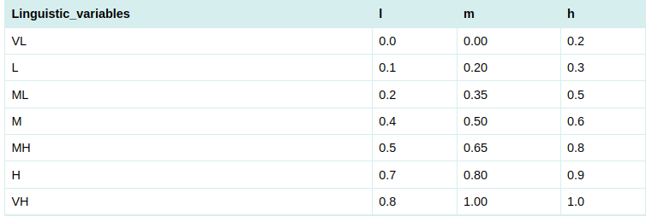

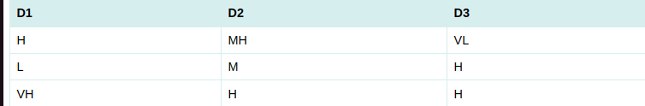Linguistic variable for importance variable of each criterion

TABLE 2.2

Assigning variable to each decision maker

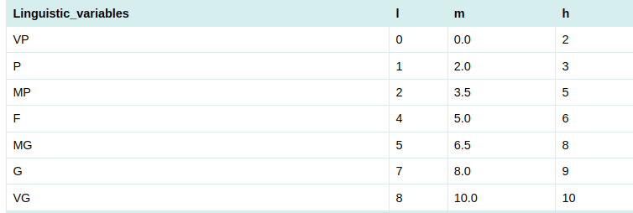Linguistic variable ratings

Table 2.3

**2.2 Assigning the rating to the alternatives**

Now the Decision makers give the ratings to the alternatives based upon the criterias.

The ratings are showed below:

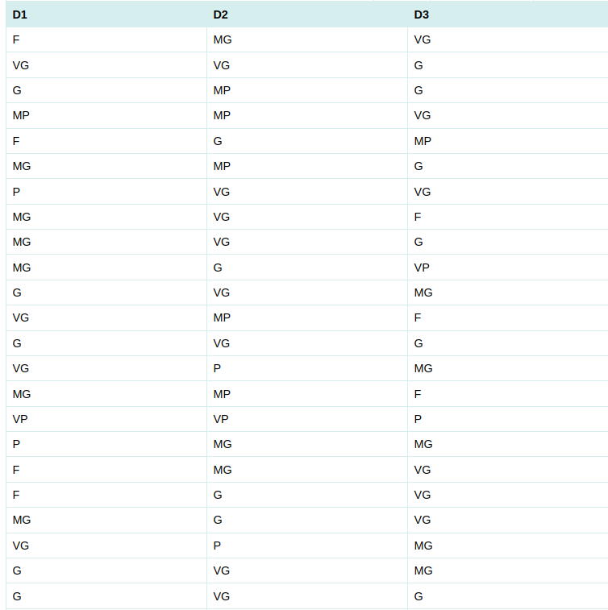

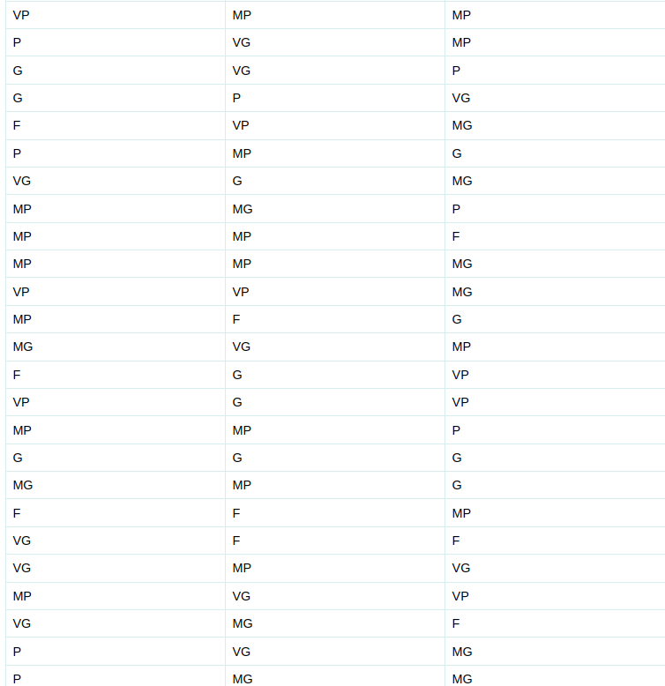

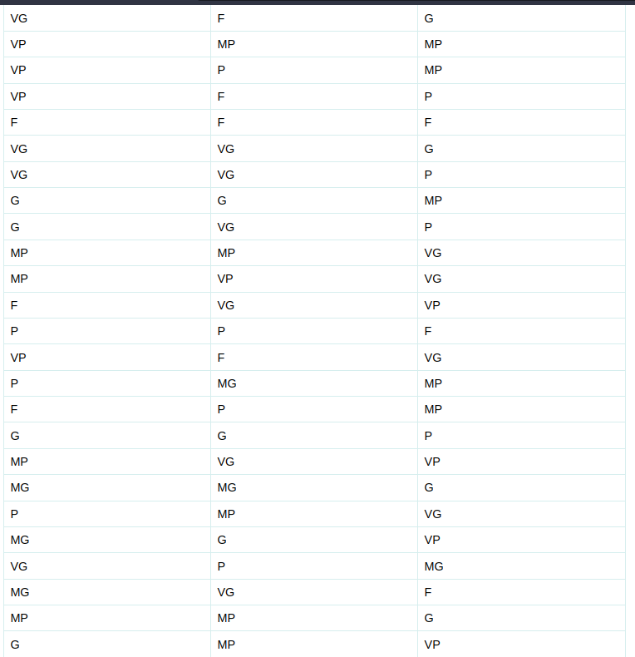

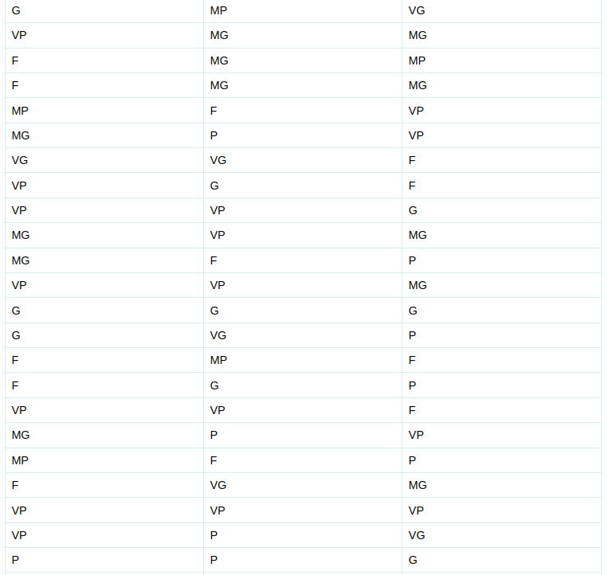

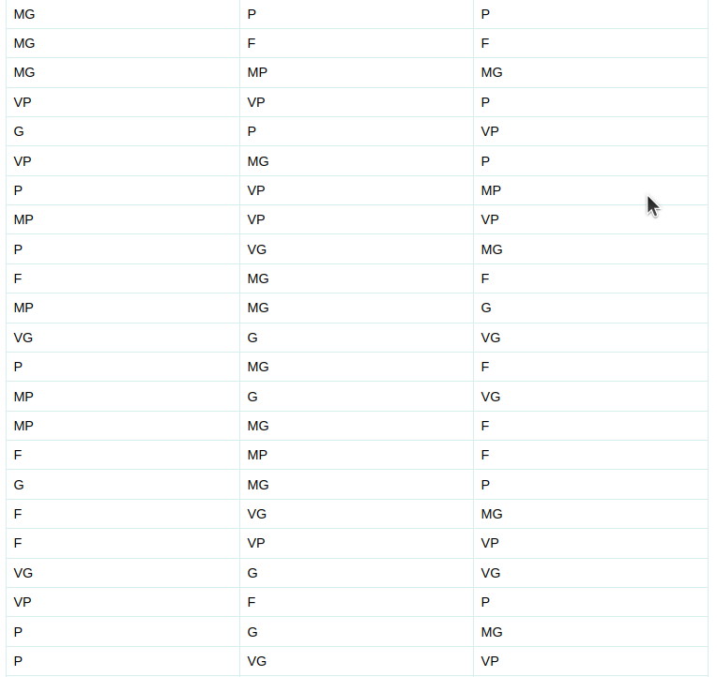

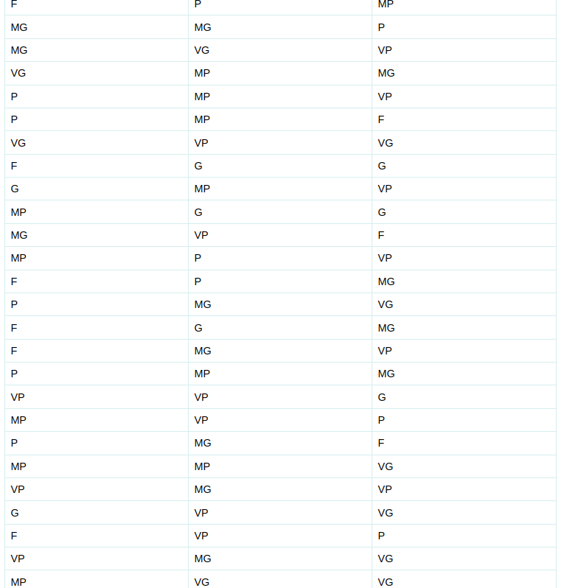

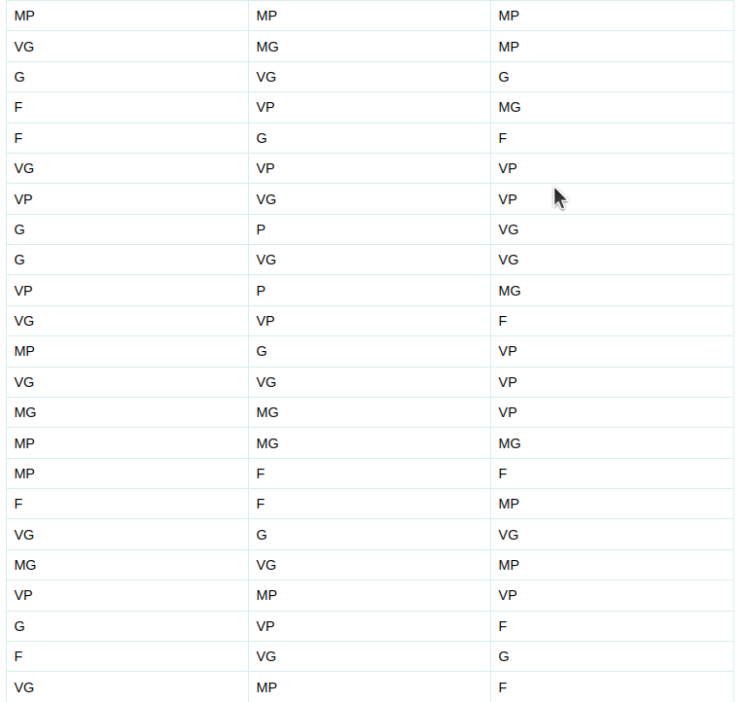

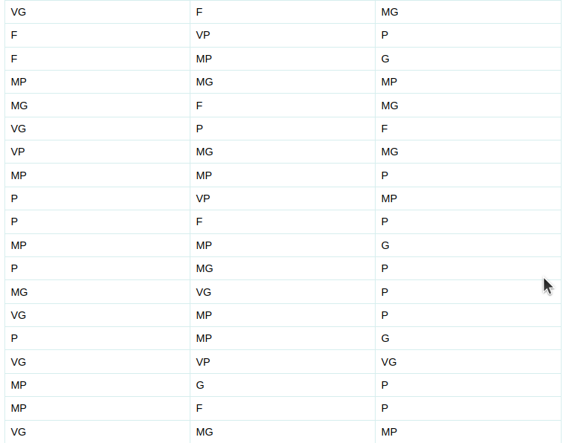

Decision makers deciding the criterion rating

Table 2.4

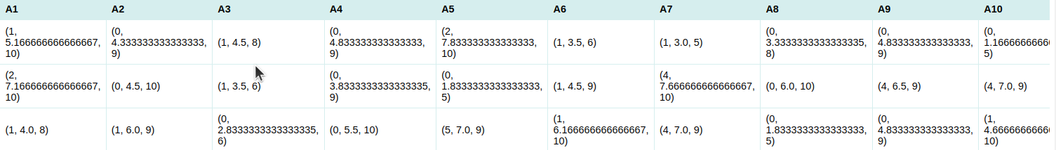2.3  **Fuzzy decision matrix and fuzzy weights**

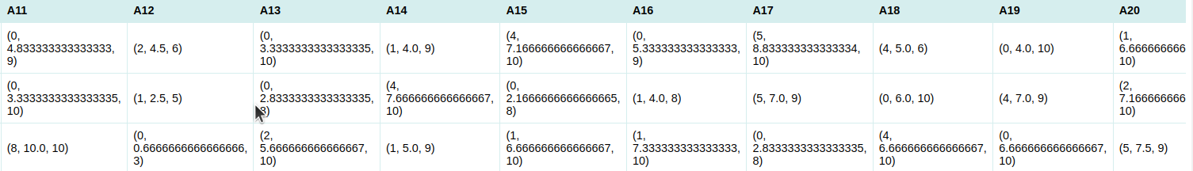

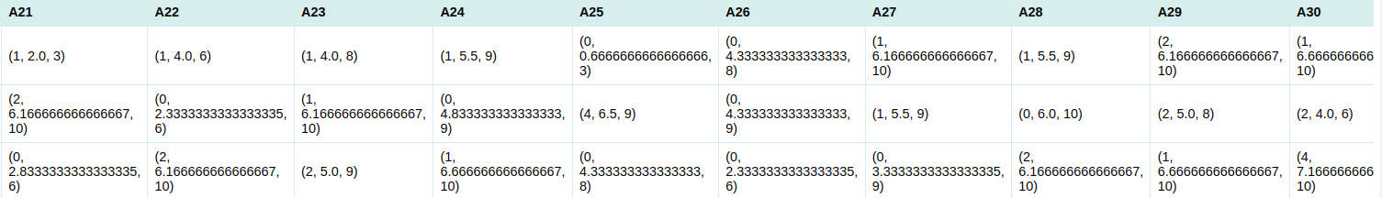

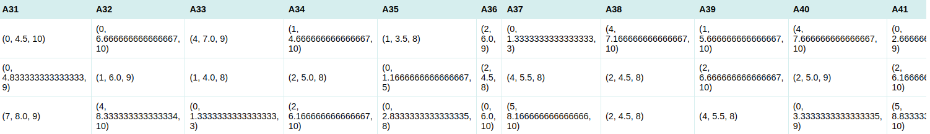

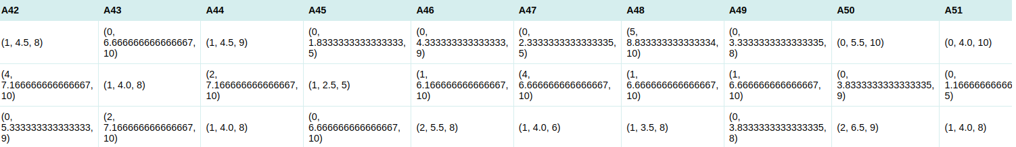

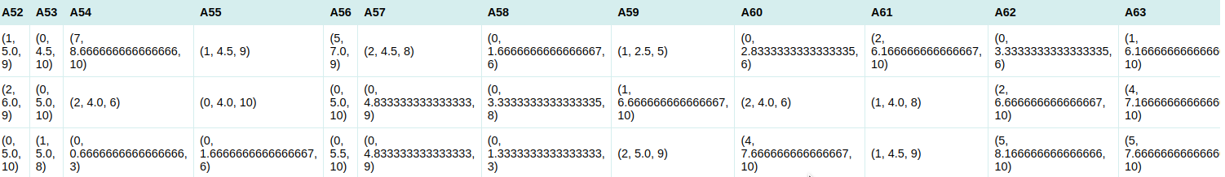Fuzzy decision matrix

Table 2.5

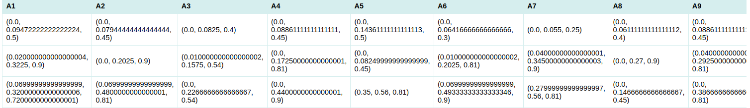

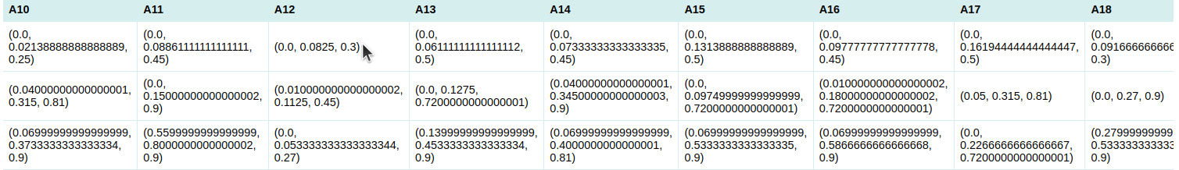

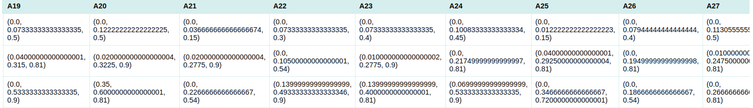

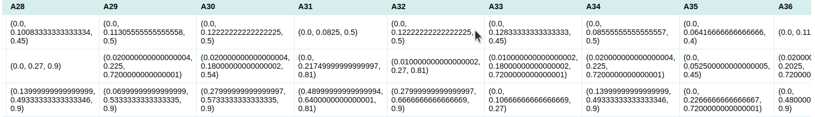

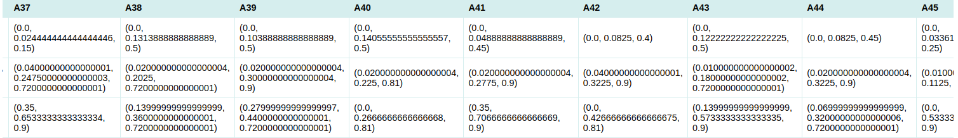

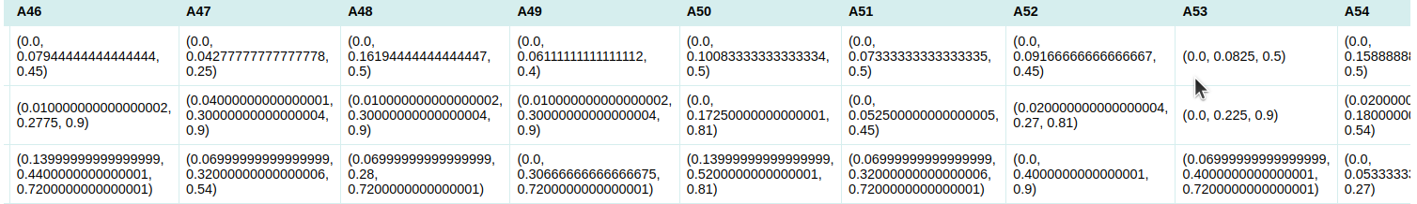

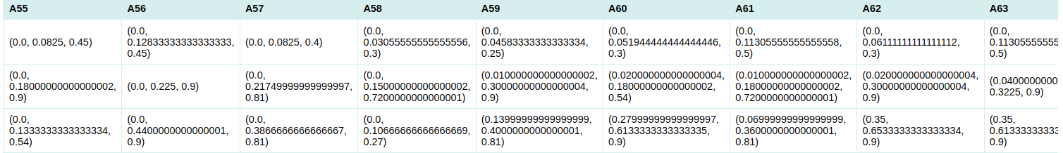

weighted normalized fuzzy matrix

Table 2.6

2.4 **Giving the ranking to the alternatives**

Now we calculate the A* and A- :

[(0.9, 0.9, 0.9), (0.4, 0.4, 0.4), (0.8, 0.8, 0.8)]

A_star

[(0.05, 0.05, 0.05), (0.010000000000000002, 0.010000000000000002, 0.010000000000000002), (0.0, 0.0, 0.0)]

A_min

Now doing calculations upon A_star and A_minus and finding the final ranking of the alternatives we get the following rating

A1 > A2 > A4 > A6 > A9 > A11> A10 > A15 > A19 A25 >A20 > A21 >A18 > A24 >A3 > A26 > A27 A13 > A12 > A14 > A22 > A23 > A16 > A17 > A8 A28 > A7 > A5 > A33 > A31 >A29 > A32 > A34 A30 > A35 > A36 > A38 >A39 > A37 > A54 > A42 A53 > A55 > A56 > A57 >A62 > A40 > A61 > A60 A58 > A41 > A59 >A63 >A52 >A50 > A43 > A51 A49 > A48 > A47 > A44> A45> A46

This is the alternatives final rating . Preference is given by this order only.

2.5 **CONCLUSION**

We use the fuzzy topsis method to find the rating of the alternatives. We select the commitee of the decision makers and then they assign ratings to each alternative according to the criteria and after we calculate the fuzzy weights and then we find FPIS and FNIS and the distance of each alternative from the them and then we calculate the final rating and based upon them the ranking is given to the alternatives and order is given.

**Chapter 3:**

The aim of this chapter is to discuss…..

**3.1 Intoduction**

**3.2 Implementing the login module**

**3.2.1 Implementing admin page**

**3.2.2 Implementing librarian login page**

**3.2.3 Implementing user login module**

**3.2.3.1 Implementing registration form for new users**

**3.2.3.2 implementing login module for current users**

3.1 Introduction

A basic website is developed for the library and all the basic features are included in it . The Web application mainly uses flask,Html and css . The basic module for now contains a front page, a page for the admin login, a page for librarian login and a page for the user. The user page contains the option for registration for the new users and an option of login for continuing users . The front page is :

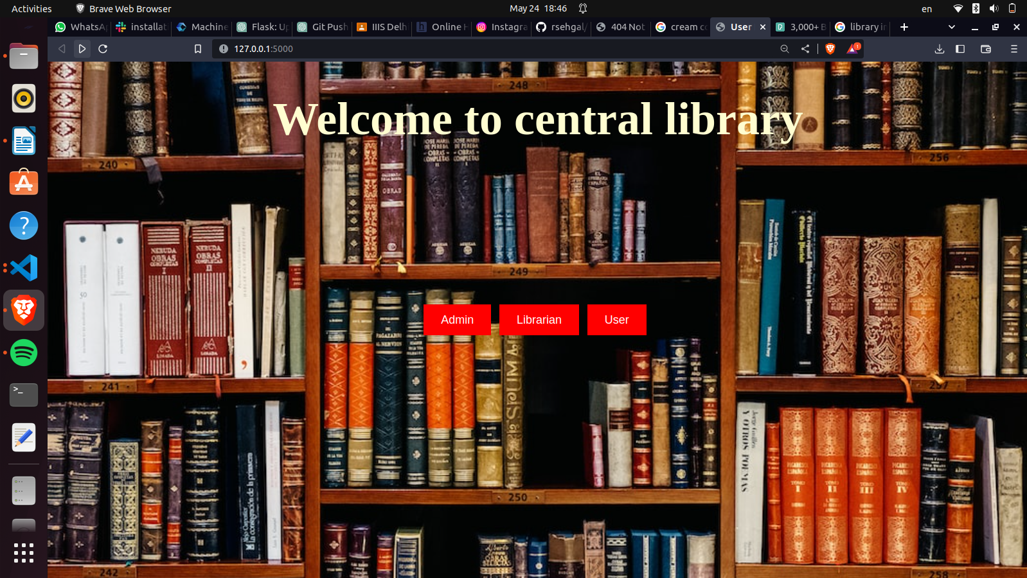

Fig 3.1

3.2.1 Implementing Admin login module

Admin of the library will be allowed to login in the system and will be able to see the working of the whole library and the information regarding the vendors as well.The admin page is :

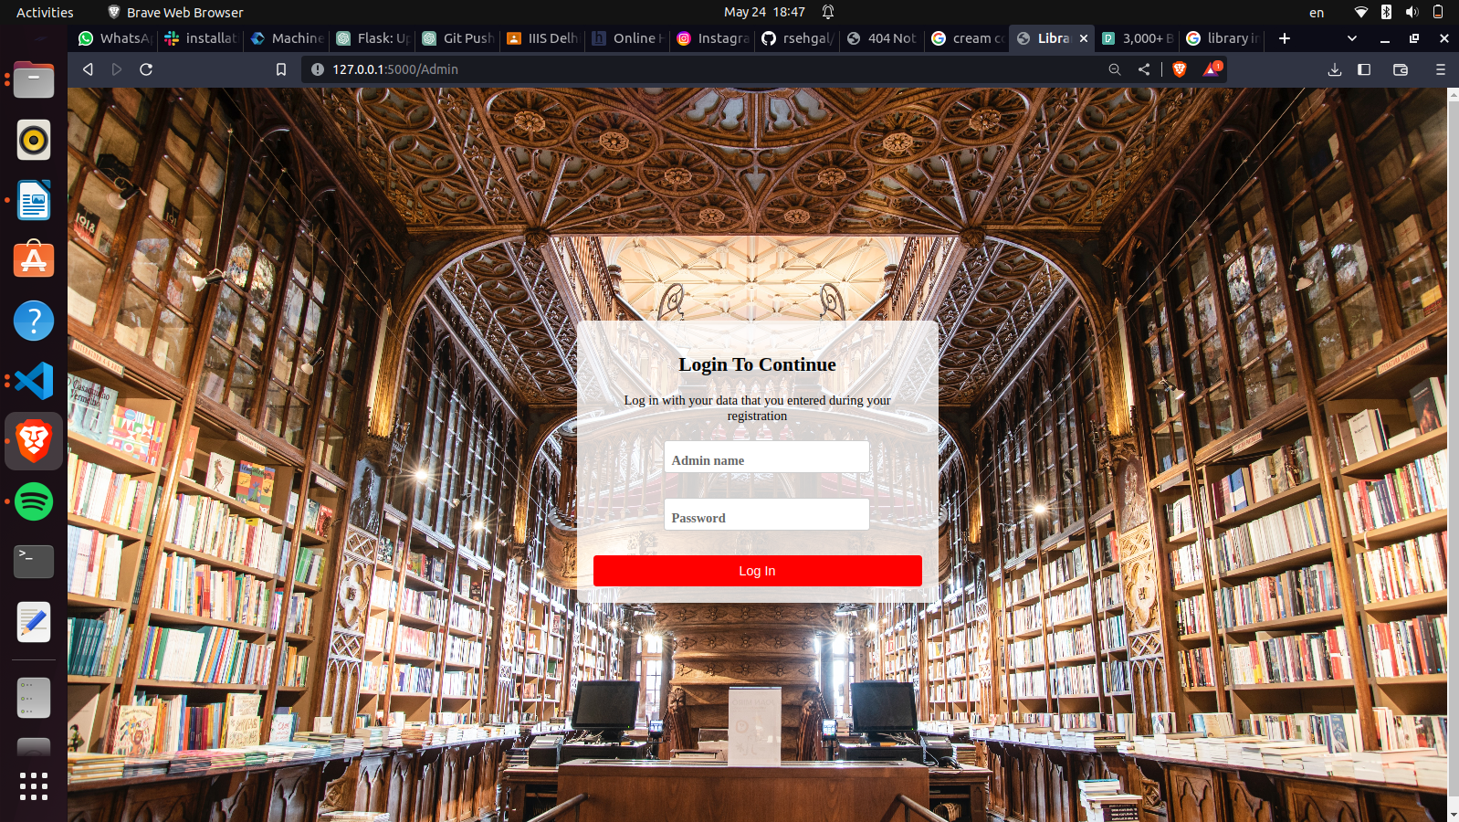Fig 3.2

3.2.1 Implementing Librarian login module

This library works on the principal that there can be multiple librarians. They can be even assigned diffferent sections of the library.So to facilate this different librarians will have their own passwords.

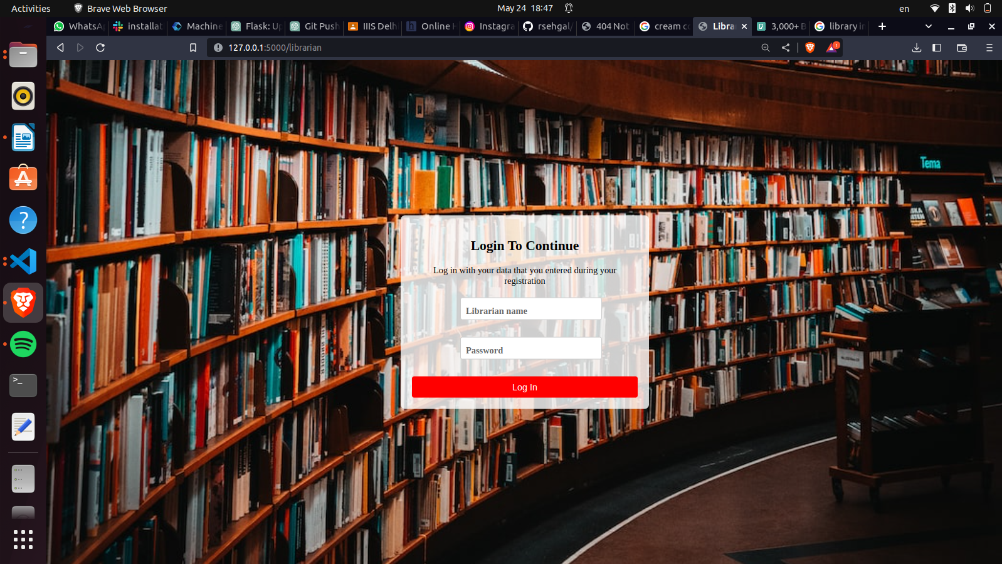

Fig 3.3

3.2.3 Implementing user login module

The user will be asked if he/she is a new user or a continuing one.For a new user a registration form option is facilitated and for the continuing user login option is present.

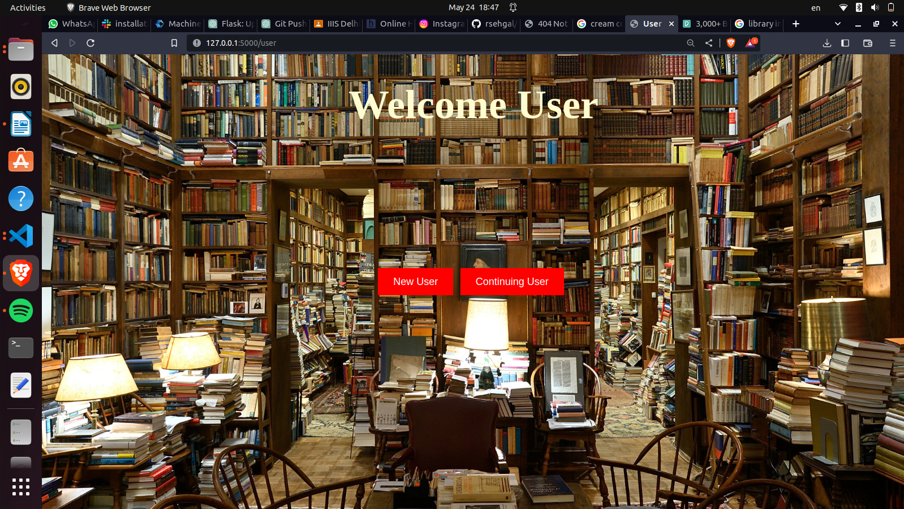

Fig 3.4

3.2.3.1 Implementing Registration form

User will be asked basic information for the registration.

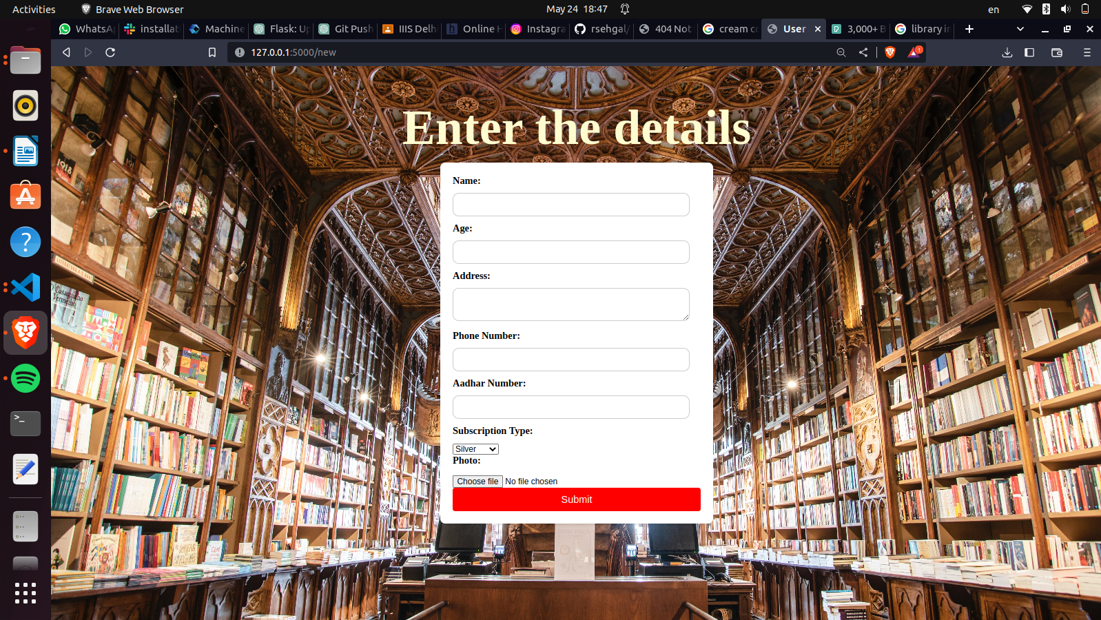

Fig 3.5

3.2.3.2 Login module for users

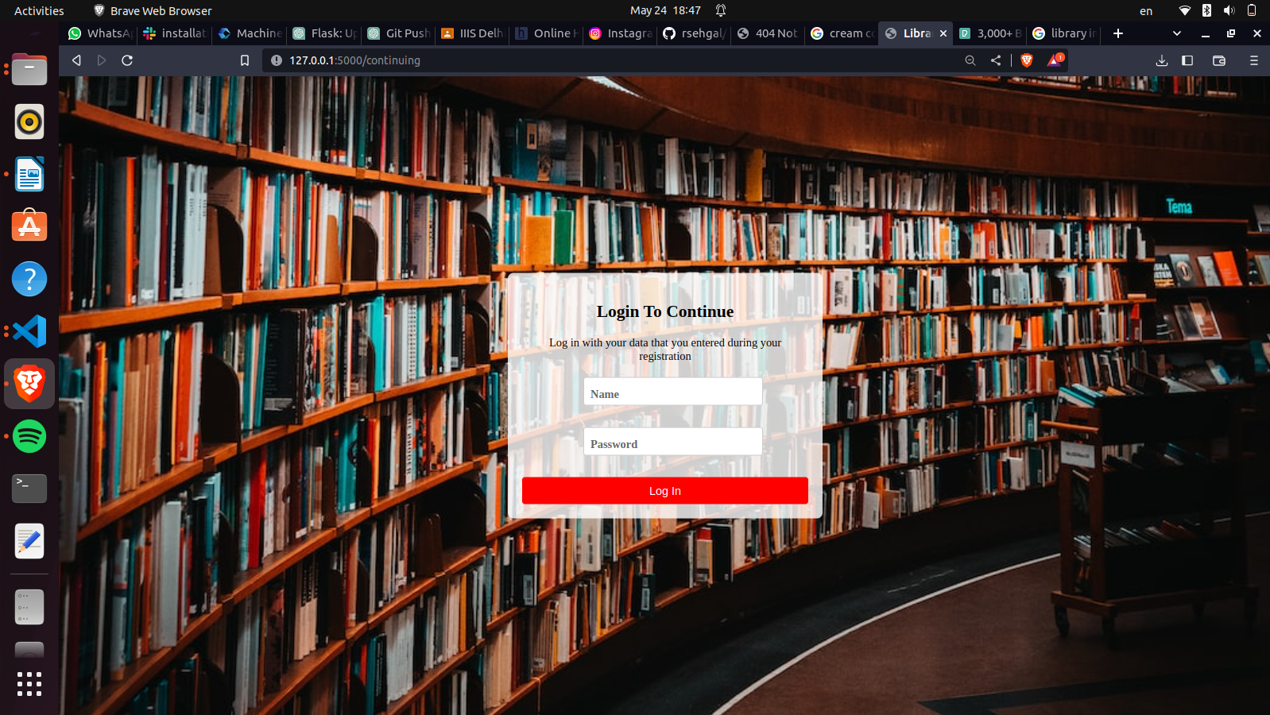

Fig 3.6

**Chapter 4:**

The aim of this chapter is to discuss…..

**4.1 Future Work**

4.1 Future Work

The complete website can be developed and deployed.

Some future works are:

1.Integration with Online Bookstores:The system's functionality can be extended to allow users to browse and purchase books directly from online bookstores. This integration would provide users with a wider range of book options and enhance their overall experience.

2.Mobile Application Development: A mobile application can be developed for the system to provide users with the convenience of accessing the library services and managing their subscriptions on their smartphones or tablets. The application could include features such as book recommendations, personalized reading lists, and push notifications for due dates and new releases.

3.Digital Content Management: The system can be extended to handle digital content, such as e-books and audiobooks. This would involve integrating with digital libraries or partnering with e-book vendors to offer a digital borrowing service. Implement features like digital rights management and support for various file formats to ensure secure and seamless access to digital content.

4.Data Analytics and Recommendation System: Data analytics capabilities can be implemented to gain insights into user preferences, popular genres, and book circulation patterns. This data can be leveraged to develop a recommendation system that suggests books based on users' reading history and interests, enhancing the user experience and encouraging more engagement with the library's offerings.

5.Online Community and Discussion Forums: An online community can be created within the system where users can interact with fellow readers, share book reviews, and participate in discussion forums. This would foster a sense of community among library members and encourage knowledge sharing and engagement with the library's resources.

6.Integration with Social Media Platforms: Users can be enabled to connect their social media accounts to the system, allowing them to share their reading activities, recommend books, and engage with the library's social media presence. This integration can help increase the library's visibility and attract new users.

7.Enhanced Security Measures: The system's security measures can be continuously improved to protect user data, prevent unauthorized access, and mitigate potential security threats. Measures such as two-factor authentication, encryption of sensitive information, and regular security audits to ensure the system remains secure and reliable can be implemented.

These future work directions can further enhance the proposed system's functionality, user experience, and overall effectiveness in managing library operations and serving the needs of library patrons.

5. REFERENCES:

* <https://doi.org/10.1080/03772063.2021.1973593>
* https://drive.google.com/file/d/1-lTyJhJm2R5W5URqyPp3c5ACP0dOBIXm/view?usp=drive_web&authuser=0

LINK FOR THE GITHUB REPO FOR THE WEBSITE:

* https://github.com/purple0608/Library_management